**Chinook SQL Queries- MS SQL Server**

* 1. **Total sales**

select sum (total) as Total_sales from invoice;

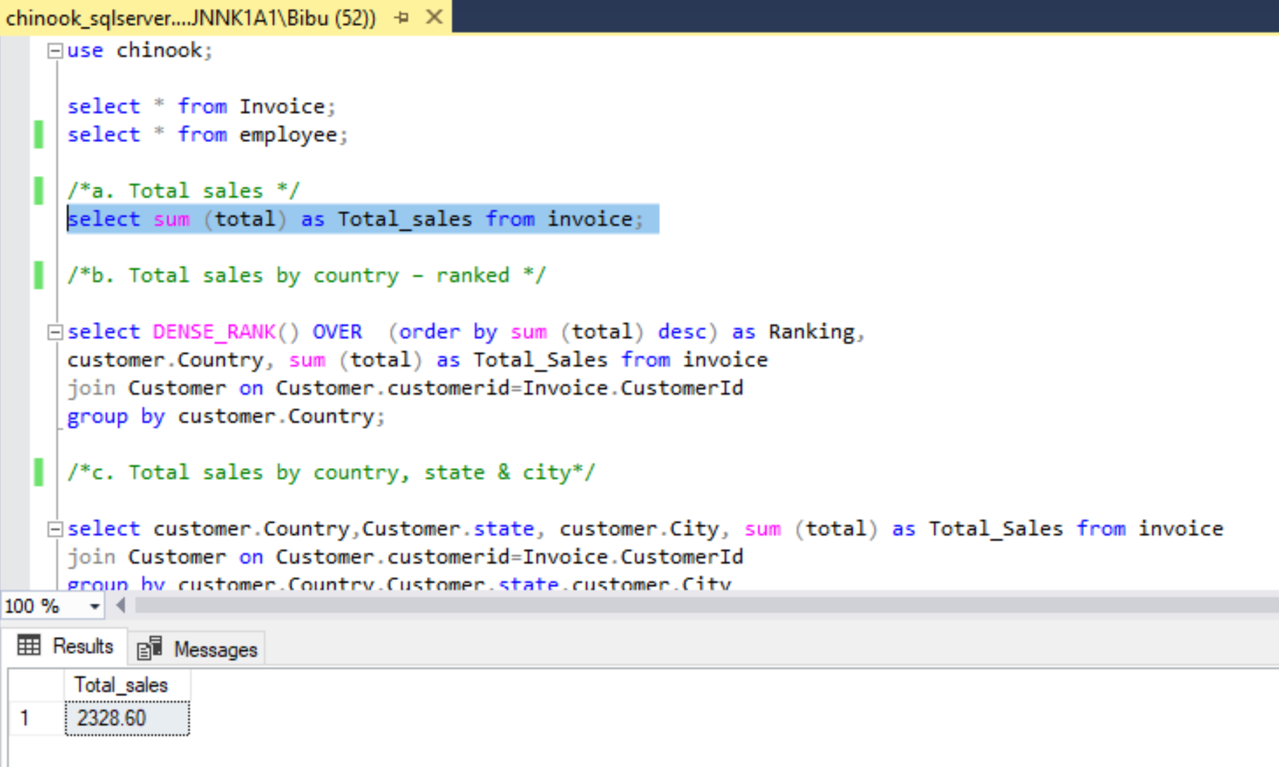

* 1. **Total sales by country – ranked**

select DENSE_RANK() OVER (order by sum (total) desc) as Ranking,

customer.Country, sum (total) as Total_Sales from invoice

join Customer on Customer.customerid=Invoice.CustomerId

group by customer.Country;

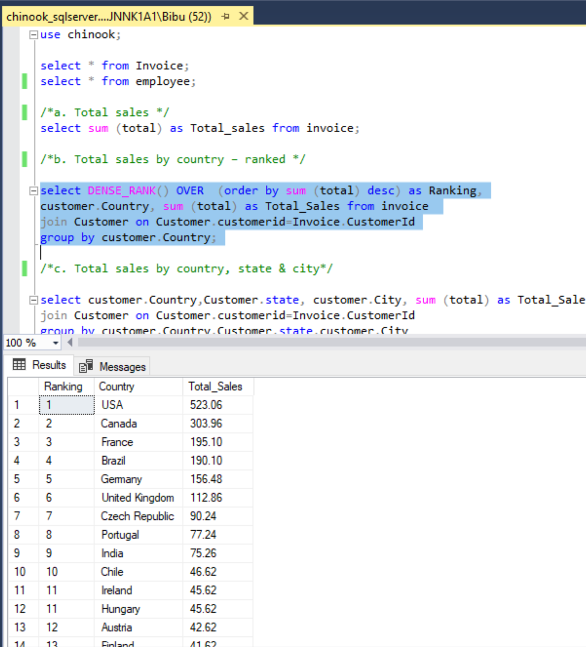

* 1. **Total sales by country, state & city**

select customer.Country,IsNull(Customer.state, '') as State, customer.City, sum (total) as Total_Sales

from invoice join Customer on Customer.customerid=Invoice.CustomerId

group by customer.Country,Customer.state,customer.City

order by customer.country;

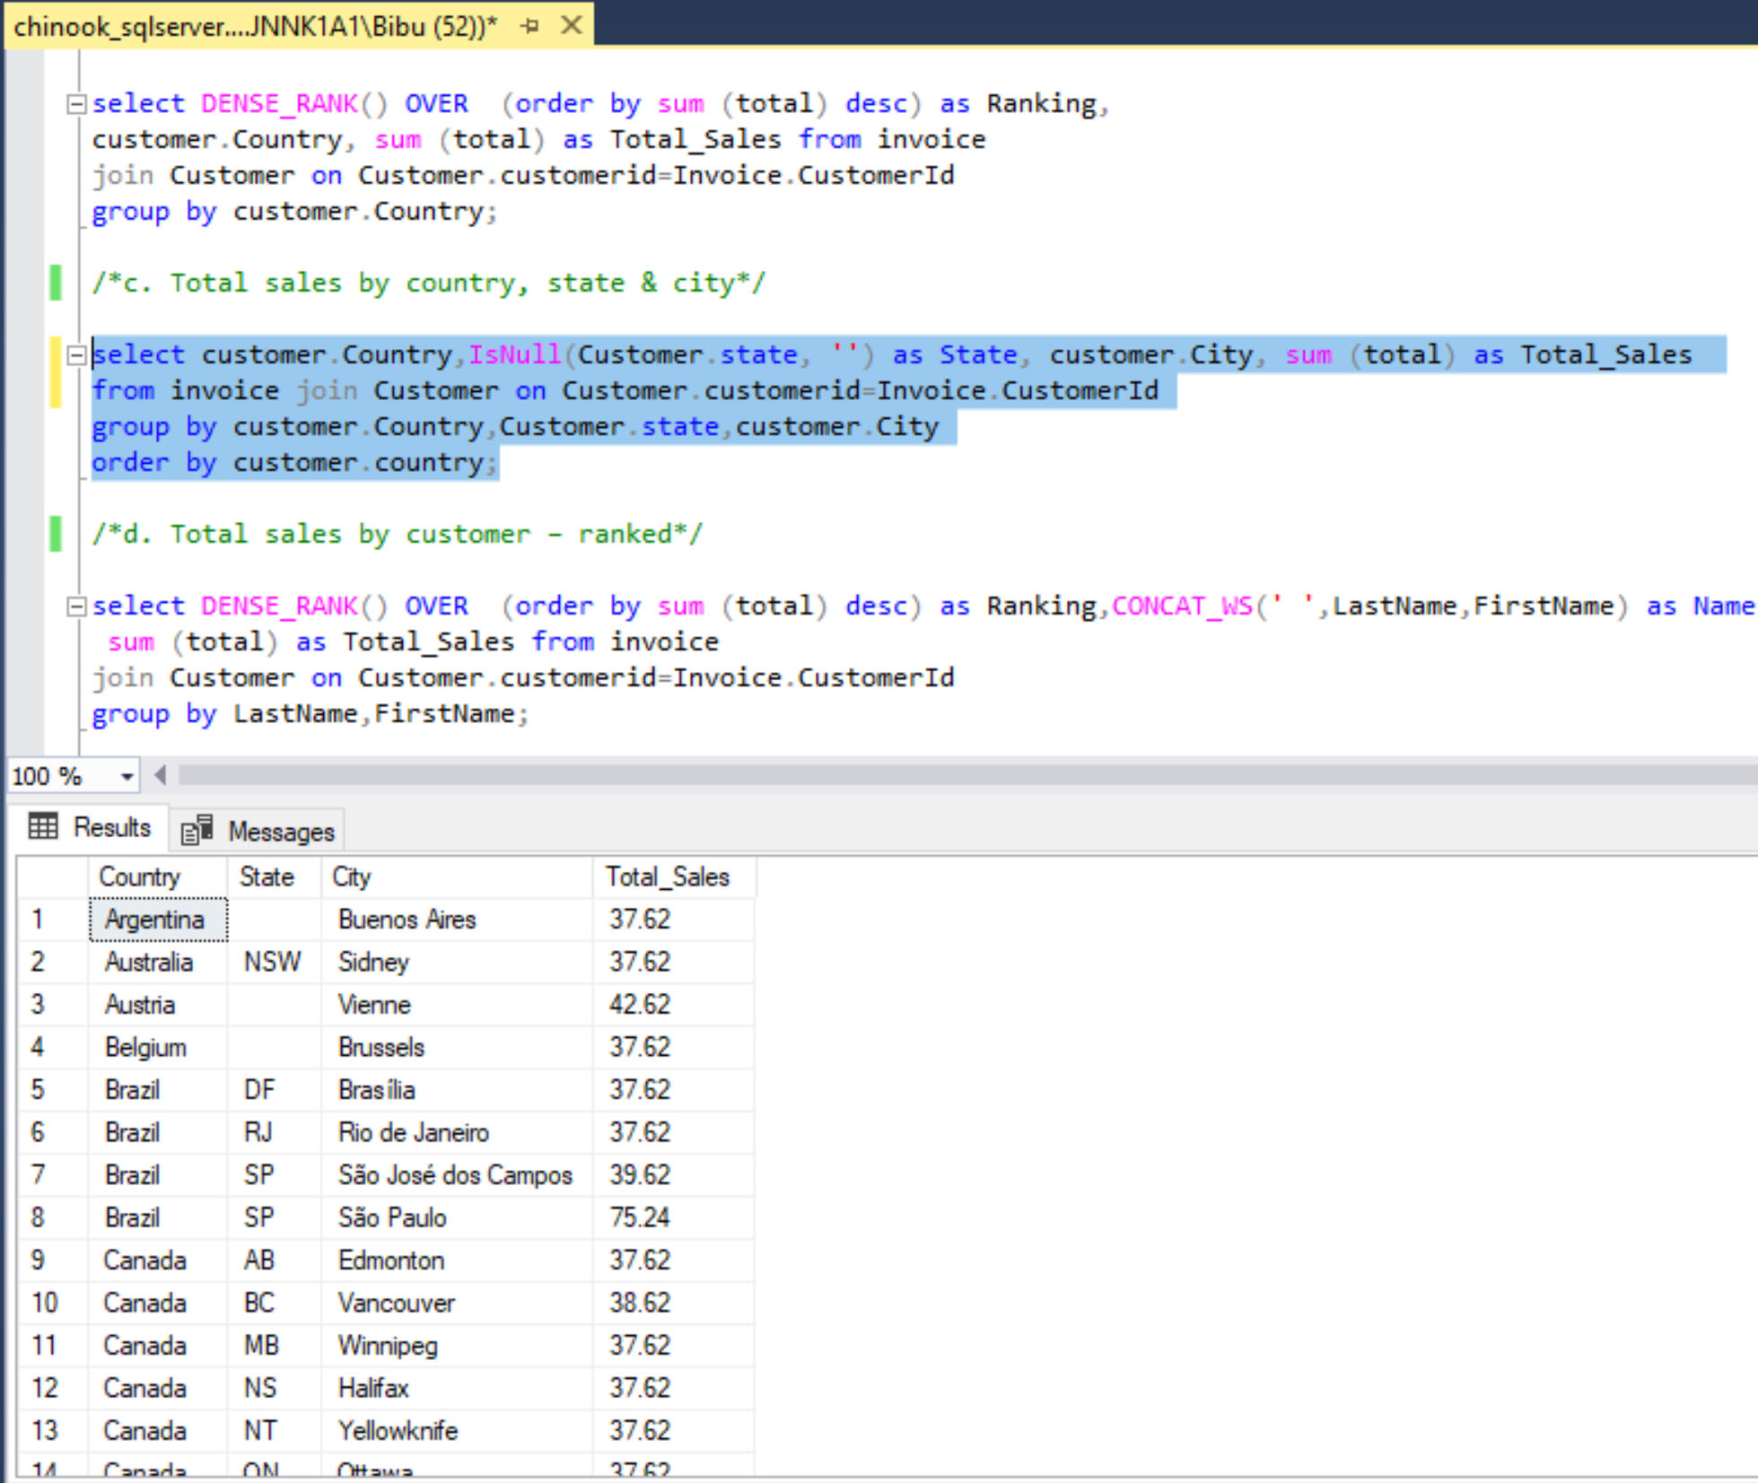

* 1. **Total sales by customer – ranked**

select DENSE_RANK() OVER (order by sum (total) desc) as Ranking,

CONCAT_WS(' ',LastName,FirstName) as Name,

sum (total) as Total_Sales from invoice

join Customer on Customer.customerid=Invoice.CustomerId

group by LastName,FirstName;

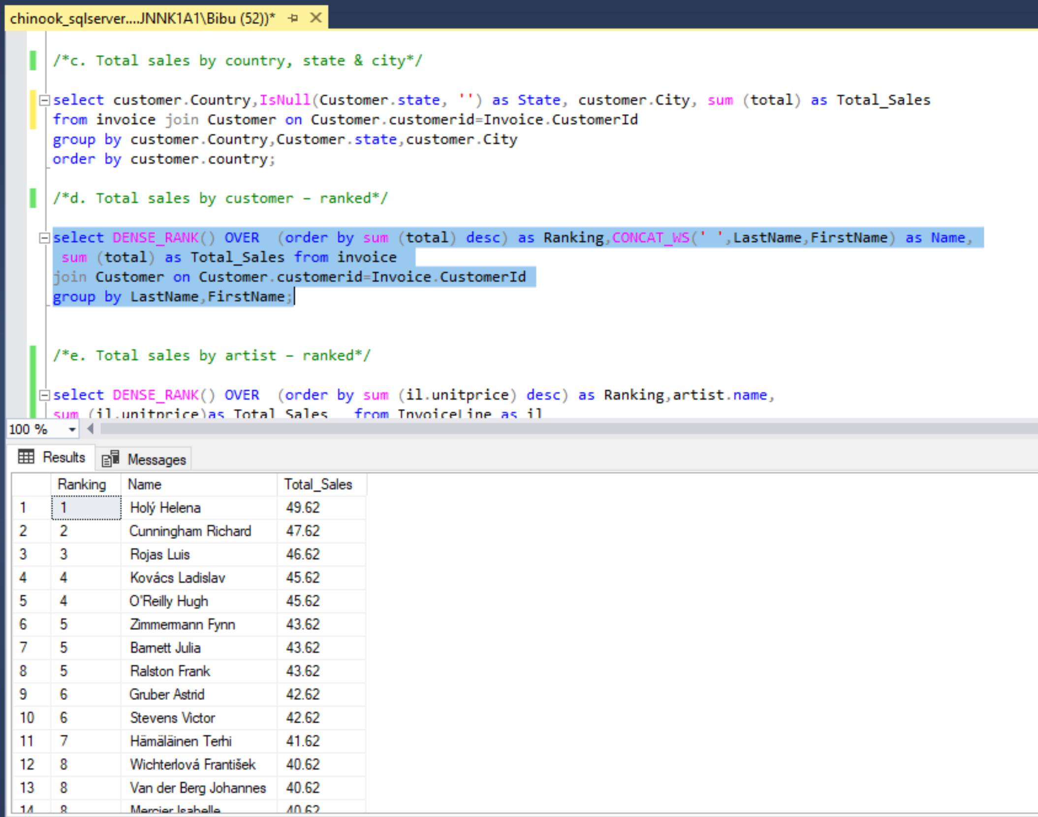

* 1. **Total sales by artist – ranked**

select DENSE_RANK() OVER (order by sum (il.unitprice) desc) as Ranking,artist.name,

sum (il.unitprice)as Total_Sales from InvoiceLine as il

join track on Track.TrackId=il.TrackId

join album on album.AlbumId=track.AlbumId

join artist on Artist.ArtistId=Album.artistid

group by artist.name;

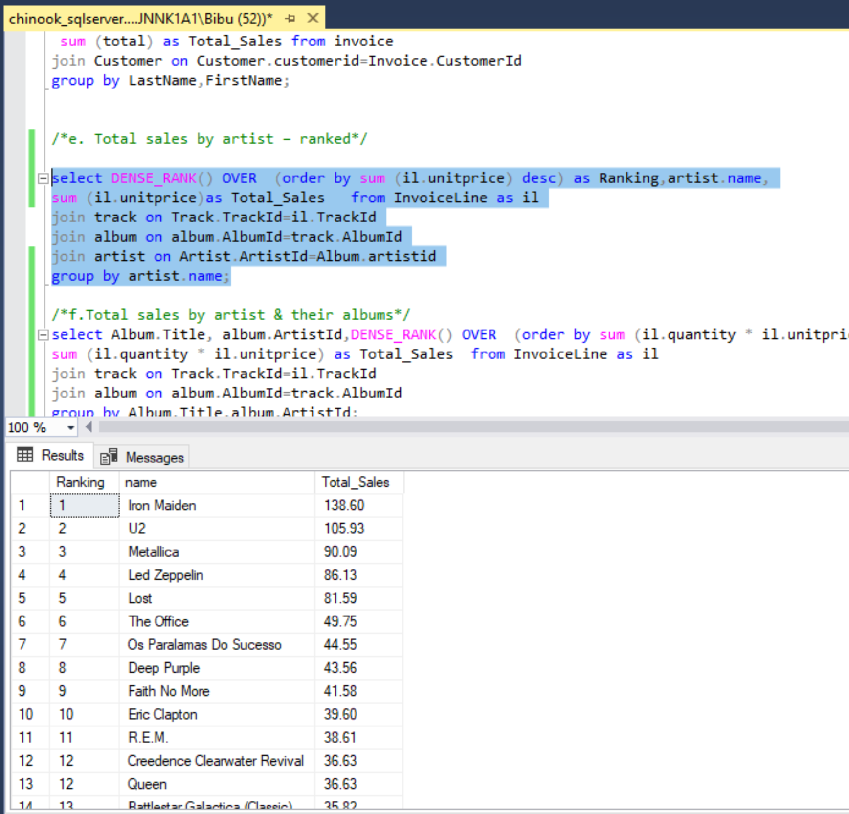

* 1. **Total sales by artist & their albums**

select Album.Title, album.ArtistId,DENSE_RANK() OVER (order by sum (il.quantity * il.unitprice) desc) as Ranking,

sum (il.quantity * il.unitprice) as Total_Sales from InvoiceLine as il

join track on Track.TrackId=il.TrackId

join album on album.AlbumId=track.AlbumId

group by Album.Title,album.ArtistId;

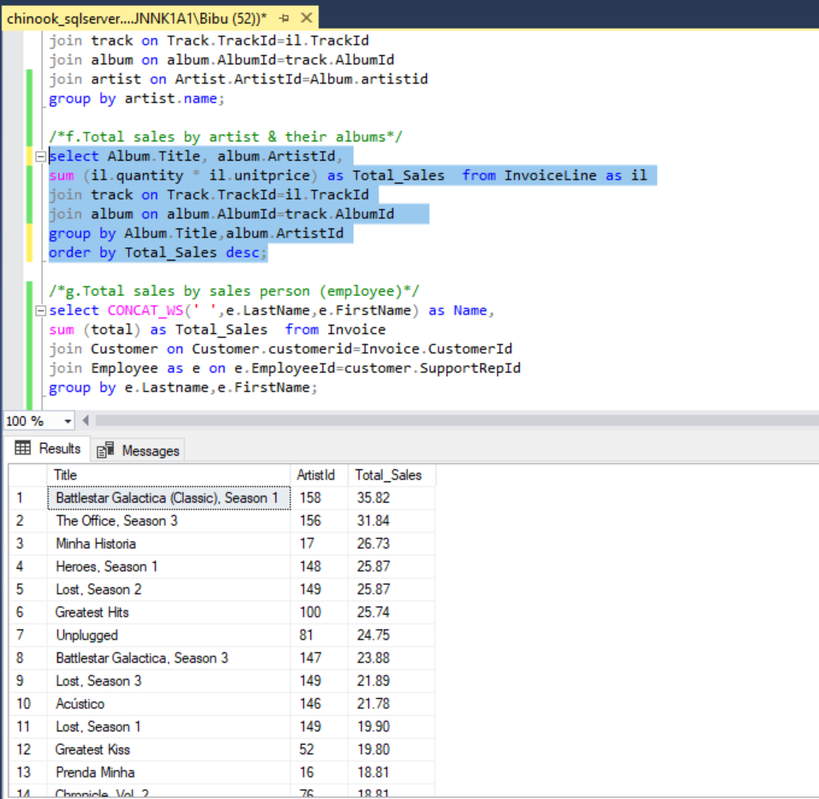

* 1. **Total sales by sales person (employee)**

select CONCAT_WS(' ',e.LastName,e.FirstName) as Name,

sum (total) as Total_Sales from Invoice

join Customer on Customer.customerid=Invoice.CustomerId

join Employee as e on e.EmployeeId=customer.SupportRepId

group by e.Lastname,e.FirstName;

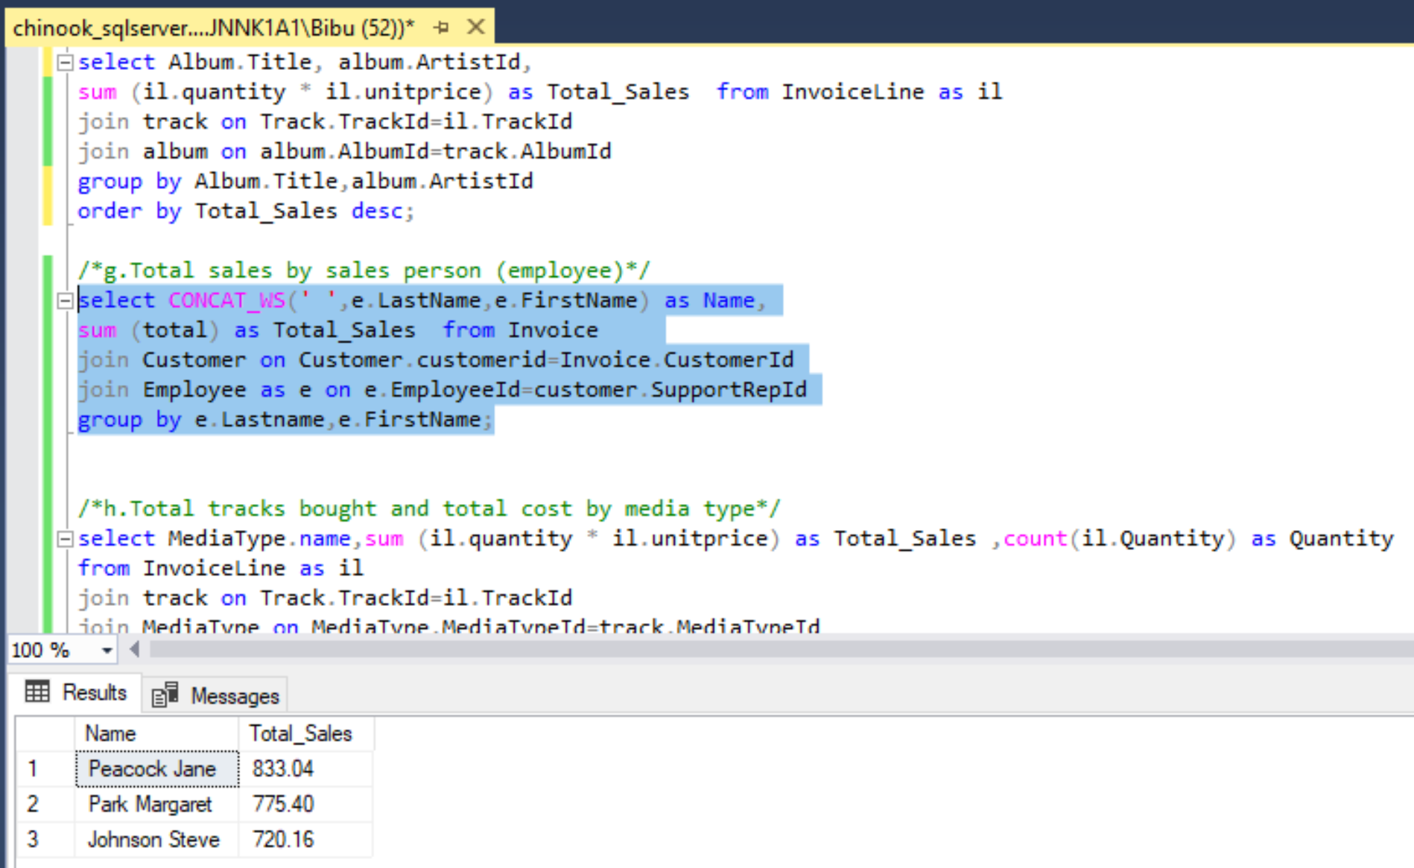

* 1. **Total tracks bought and total cost by media type**

select MediaType.name,sum (il.quantity * il.unitprice) as Total_Sales, count(il.Quantity) as Quantityfrom InvoiceLine as il

join track on Track.TrackId=il.TrackId

join MediaType on MediaType.MediaTypeId=track.MediaTypeId

group by MediaType.name,il.Quantity

order by Total_Sales desc;

